Supplementary Materials
List of supplementary materials
- Supplementary Figure 1. Manhattan plots of p-values of 5,375,073 SNPs obtained by a meta-analysis of two HBV-related HCC GWASs in Chinese populations.
- Supplementary Figure 2. The quantile-quantile plots of p-values of 5,375,073 SNPs obtained by a meta-analysis of two HBV-related HCC GWASs in Chinese populations.
- Supplementary Figure 3. Regulatory annotations at gene WHAMMP2.
- Supplementary Figure 4. Visualization of regulatory annotation at rs17343667 by RegulomeDB.
- Supplementary Table 1. Genetic association p-values of genes preferentially expressed in liver.
- Supplementary Table 2. Association p-values of genes frequently intergraded by HBV
- Supplementary Table 3. Association p-values of genes with significant association in previous studies
- Supplementary Table 4. Association p-values of COSMIC HCC risk genes.
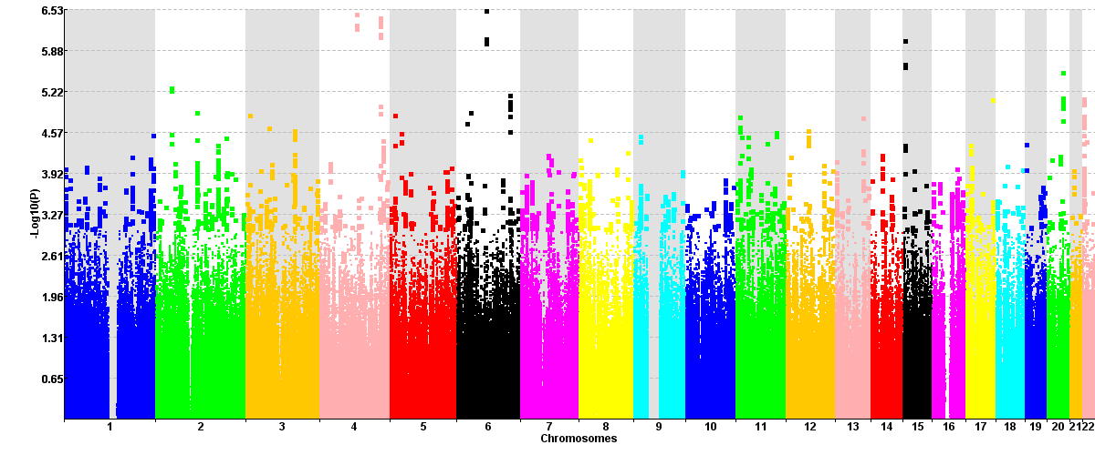
Supplementary Figure 1. Manhattan plots of p-values of 5,375,073 SNPs obtained by a meta-analysis of two HBV-related HCC GWASs in Chinese populations. The p-values are taken –log10 to visualize significance of small p-values.

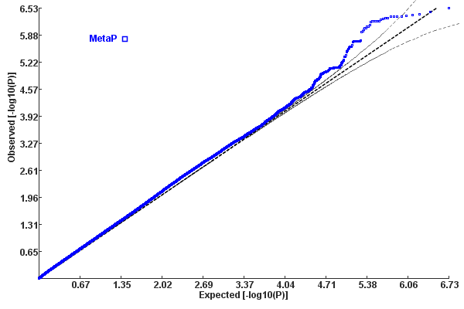
Supplementary Figure 2. The quantile-quantile plots of p-values of 5,375,073 SNPs obtained by a meta-analysis of two HBV-related HCC GWASs in Chinese populations.

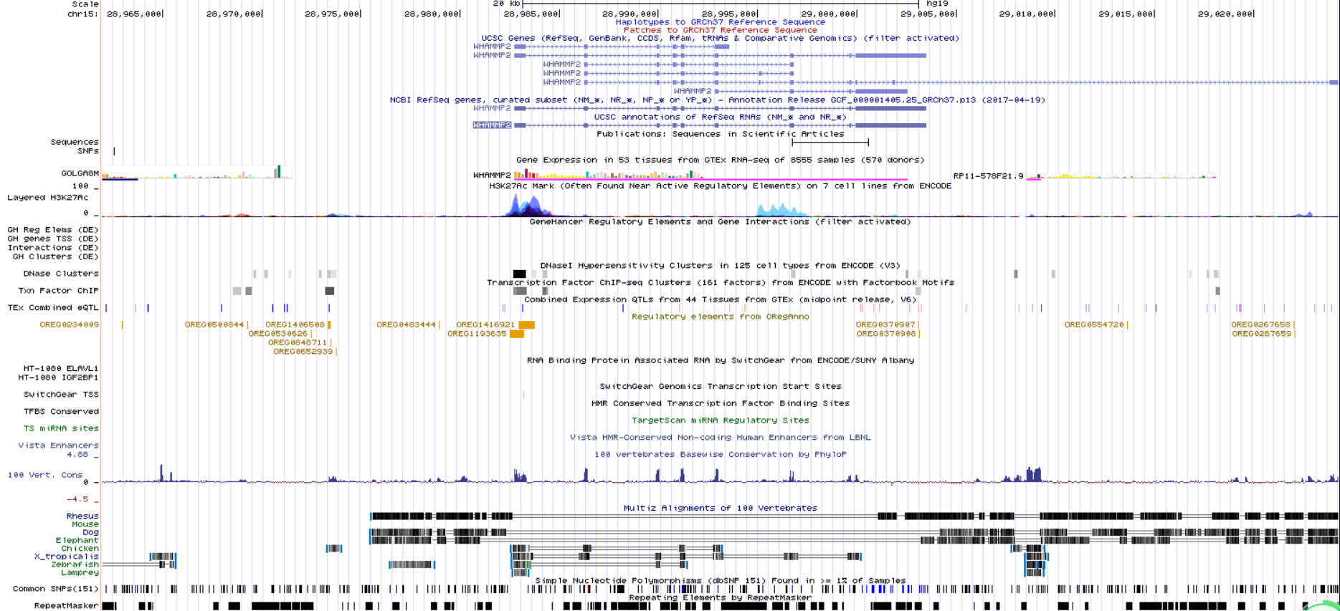
Supplementary Figure 3. Regulatory annotations at gene WHAMMP2. This plot is produced by UCSC genome browser (http://genome.ucsc.edu). The regulatory options (ENCODE Regulation, Chromatin Interactions, DNA Methylation, Histone Modification, Transcription Factor Binding Tracks, Regulatory elements from ORegAnno, CD34 DnaseI, and Vista Enhancers) were turned on.

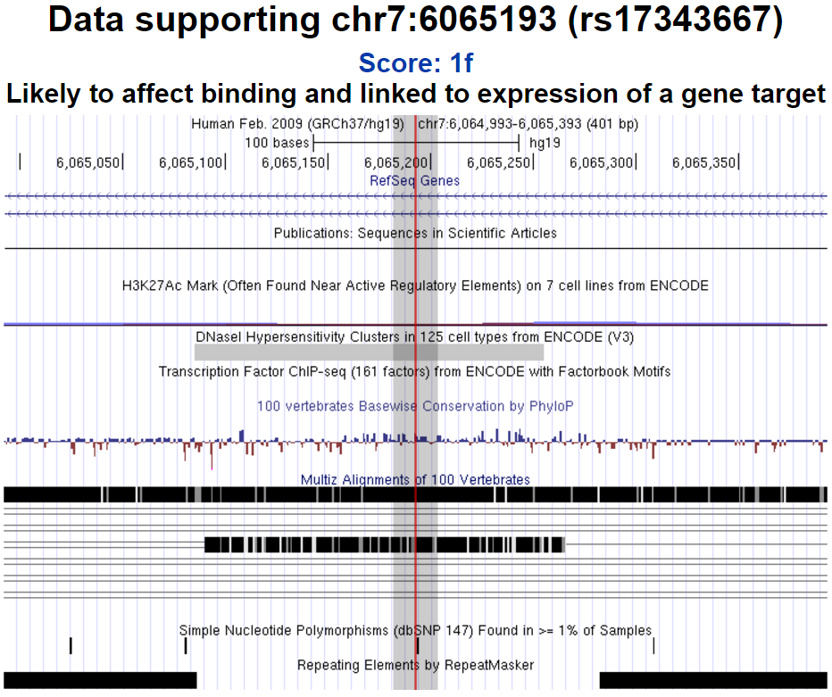
Supplementary Figure 4. Visualization of regulatory annotation at rs17343667 by RegulomeDB. This plot is produced by RegulomeDB (http://www.regulomedb.org) with RS ID.

Supplementary Table 1. Genetic association p-values of genes preferentially expressed in liver
Symbol | GATES-P | ECS-P | CHR | Start Position | Length (BP) | Number of SNPs
PAH | 0.24765 | 0.00035 | 12 | 103230666 | 80356 | 266
UGT2B10 | 0.01504 | 0.00079 | 4 | 69870294 | 172553 | 122
UROC1 | 0.02728 | 0.00138 | 3 | 126200008 | 36608 | 92
TF | 0.00293 | 0.01388 | 3 | 133465236 | 50249 | 288
C4A | 0.06735 | 0.01472 | 6 | 31949833 | 20624 | 20
SLCO1B1 | 0.13535 | 0.01528 | 12 | 21284127 | 108603 | 298
C5 | 0.21972 | 0.01605 | 9 | 123761950 | 50603 | 150
GSTA2 | 0.04013 | 0.01864 | 6 | 52614884 | 13389 | 59
C4B | 0.129 | 0.02012 | 6 | 31982571 | 12113 | 38
HAO1 | 0.03276 | 0.02195 | 20 | 7863631 | 57474 | 118
NAT2 | 0.01023 | 0.02308 | 8 | 18248791 | 9934 | 70
C4BPA | 0.24822 | 0.0511 | 1 | 207277577 | 40740 | 71
TAT | 0.09868 | 0.05446 | 16 | 71599562 | 11433 | 26
AGXT2 | 0.09673 | 0.05659 | 5 | 34998206 | 49848 | 215
TDO2 | 0.28695 | 0.06283 | 4 | 156824847 | 16711 | 54
F2 | 0.18784 | 0.06361 | 11 | 46740762 | 20294 | 28
SLCO1B3 | 0.05607 | 0.06376 | 12 | 20975481 | 94362 | 536
LRG1 | 0.10587 | 0.06444 | 19 | 4536413 | 3635 | 6
APOH | 0.16442 | 0.06527 | 17 | 64208150 | 17383 | 79
ASGR1 | 0.07453 | 0.07133 | 17 | 7076750 | 5939 | 6
C8B | 0.31258 | 0.08504 | 1 | 57394882 | 36806 | 97
CYP2A7 | 0.13973 | 0.08514 | 19 | 41381343 | 7314 | 87
FGL1 | 0.06307 | 0.08788 | 8 | 17721899 | 31014 | 197
SERPINA3 | 0.28537 | 0.09628 | 14 | 95078727 | 11663 | 39
FETUB | 0.32071 | 0.09832 | 3 | 186358187 | 12743 | 48
GSTA1 | 0.01104 | 0.10232 | 6 | 52656170 | 12444 | 50
RBP4 | 0.07854 | 0.10538 | 10 | 95351592 | 9400 | 44
ALDH8A1 | 0.12476 | 0.10623 | 6 | 135238530 | 32709 | 65
CYP3A7 | 0.14214 | 0.1099 | 7 | 99302658 | 30161 | 56
CPB2 | 0.12493 | 0.1235 | 13 | 46627321 | 51847 | 156
FGG | 0.07183 | 0.13238 | 4 | 155525322 | 8486 | 18
APOA2 | 0.04277 | 0.13816 | 1 | 161192081 | 1337 | 22
AMBP | 0.19443 | 0.14423 | 9 | 116822407 | 18173 | 79
HRG | 0.1571 | 0.14658 | 3 | 186383802 | 12221 | 62
APOM | 0.28606 | 0.14685 | 6 | 31623670 | 2317 | 28
HABP2 | 0.42501 | 0.14977 | 10 | 115312811 | 36549 | 169
INHBC | 0.23798 | 0.15154 | 12 | 57828566 | 17279 | 39
AQP9 | 0.03199 | 0.15963 | 15 | 58430579 | 47531 | 182
SERPINA1 | 0.31716 | 0.1627 | 14 | 94843083 | 11856 | 56
FMO3 | 0.28652 | 0.16545 | 1 | 171060045 | 26914 | 108
SERPINC1 | 0.12826 | 0.16577 | 1 | 173872941 | 13524 | 37
NR1H4 | 0.2477 | 0.16933 | 12 | 100897137 | 61055 | 145
HSD17B6 | 0.11868 | 0.17135 | 12 | 57157107 | 24467 | 42
CYP7A1 | 0.26478 | 0.18451 | 8 | 59402736 | 9986 | 42
DPYS | 0.51541 | 0.1864 | 8 | 105391658 | 87625 | 171
C3 | 0.08473 | 0.18662 | 19 | 6677714 | 42947 | 148
ADH1C | 0.3069 | 0.18787 | 4 | 100257653 | 16250 | 107
RIDA | 0.13179 | 0.2046 | 8 | 99114571 | 14828 | 54
ASGR2 | 0.30112 | 0.20635 | 17 | 7004640 | 12989 | 120
EHHADH | 0.2643 | 0.21175 | 3 | 184908411 | 63426 | 109
CYP4F2 | 0.16832 | 0.22958 | 19 | 15988832 | 20052 | 102
ITIH4 | 0.42063 | 0.24111 | 3 | 52847005 | 17683 | 37
HAO2 | 0.3818 | 0.24778 | 1 | 119911407 | 25346 | 60
KNG1 | 0.83669 | 0.25032 | 3 | 186435147 | 27052 | 179
ORM1 | 0.14499 | 0.26023 | 9 | 117085302 | 3457 | 44
DIO1 | 0.45933 | 0.26235 | 1 | 54359859 | 16900 | 86
HPR | 0.09131 | 0.26734 | 16 | 72097124 | 14021 | 29
FGA | 0.14675 | 0.27409 | 4 | 155506426 | 5468 | 21
FMO5 | 0.2928 | 0.28831 | 1 | 146657839 | 39092 | 96
PON3 | 0.16061 | 0.28901 | 7 | 94989183 | 36504 | 56
CYP2B6 | 0.51552 | 0.29436 | 19 | 41497186 | 27117 | 101
ANG | 0.26455 | 0.30522 | 14 | 21156922 | 5420 | 41
CXCL2 | 0.36908 | 0.31573 | 4 | 74962756 | 2156 | 10
SULT2A1 | 0.28813 | 0.33316 | 19 | 48373723 | 15849 | 59
ALB | 0.36284 | 0.33414 | 4 | 74270003 | 17196 | 40
PIPOX | 0.4244 | 0.33779 | 17 | 27370158 | 14076 | 21
CPN1 | 0.67109 | 0.33873 | 10 | 101801949 | 39677 | 89
ALDOB | 0.27218 | 0.34176 | 9 | 104182841 | 15215 | 33
SERPINA5 | 0.52521 | 0.3424 | 14 | 95047762 | 11693 | 112
C8A | 0.41126 | 0.34304 | 1 | 57320469 | 63427 | 195
C9 | 0.66717 | 0.346 | 5 | 39284242 | 80355 | 207
AFP | 0.30889 | 0.35498 | 4 | 74301937 | 19954 | 34
SERPINA4 | 0.20004 | 0.35605 | 14 | 95027778 | 8465 | 53
FGB | 0.26478 | 0.358 | 4 | 155484131 | 9784 | 40
LBP | 0.05757 | 0.36365 | 20 | 36974884 | 30771 | 119
HNF4A | 0.46018 | 0.36891 | 20 | 43029895 | 23388 | 175
LECT2 | 0.72343 | 0.36989 | 5 | 135282592 | 8080 | 64
ITIH3 | 0.46727 | 0.37456 | 3 | 52828783 | 14242 | 25
PZP | 0.51725 | 0.37695 | 12 | 9301435 | 59556 | 122
GNMT | 0.47036 | 0.38272 | 6 | 42928491 | 3127 | 31
AGTR1 | 0.42532 | 0.38395 | 3 | 148447966 | 12824 | 111
SAA1 | 0.57278 | 0.38849 | 11 | 18287810 | 3704 | 38
SAA2 | 0.04169 | 0.3973 | 11 | 18266786 | 3429 | 55
SLC22A7 | 0.37945 | 0.39854 | 6 | 43265997 | 7279 | 14
F12 | 0.43851 | 0.40054 | 5 | 176829138 | 7439 | 9
GATM | 0.57238 | 0.40064 | 15 | 45653321 | 17421 | 96
CYP2E1 | 0.89995 | 0.40089 | 10 | 135340866 | 11761 | 83
ITIH1 | 0.82347 | 0.4011 | 3 | 52813941 | 12137 | 38
KHK | 0.42636 | 0.4068 | 2 | 27309639 | 13991 | 18
CYP2A6 | 0.59304 | 0.423 | 19 | 41349445 | 6907 | 30
SLC22A1 | 0.63336 | 0.42453 | 6 | 160542862 | 36888 | 71
COLEC10 | 0.78771 | 0.42512 | 8 | 120079485 | 41209 | 598
FABP1 | 0.33624 | 0.43352 | 2 | 88422507 | 5074 | 27
APOC1 | 0.83934 | 0.43464 | 19 | 45417864 | 4737 | 29
AADAC | 0.43001 | 0.43468 | 3 | 151531903 | 14373 | 101
APOA1 | 0.44757 | 0.44799 | 11 | 116706466 | 1872 | 46
NR1I3 | 0.57989 | 0.45028 | 1 | 161199458 | 8535 | 36
RDH16 | 0.4476 | 0.45155 | 12 | 57345214 | 7944 | 29
ABCC2 | 0.32495 | 0.4519 | 10 | 101542396 | 69955 | 99
HAL | 0.65067 | 0.4546 | 12 | 96366439 | 23683 | 90
AOX1 | 0.5554 | 0.45597 | 2 | 201450736 | 85481 | 210
SPP2 | 0.39463 | 0.45941 | 2 | 234959345 | 26433 | 123
SERPINA10 | 0.58996 | 0.46017 | 14 | 94749649 | 9712 | 33
SERPIND1 | 0.72654 | 0.46263 | 22 | 21128400 | 13608 | 51
APOC2 | 0.87919 | 0.46288 | 19 | 45449307 | 3515 | 61
HGD | 0.3846 | 0.4659 | 3 | 120347018 | 54068 | 38
SERPINF2 | 0.66085 | 0.46863 | 17 | 1646319 | 12240 | 57
BHMT2 | 0.66786 | 0.47169 | 5 | 78365589 | 20303 | 55
PON1 | 0.38889 | 0.48316 | 7 | 94926987 | 26857 | 88
TM4SF4 | 0.30723 | 0.49027 | 3 | 149192483 | 28698 | 177
ARG1 | 0.62552 | 0.49163 | 6 | 131894365 | 11104 | 19
HP | 0.1611 | 0.50233 | 16 | 72088490 | 6464 | 23
LIPC | 0.4996 | 0.50266 | 15 | 58724189 | 137854 | 411
VTN | 0.45691 | 0.51054 | 17 | 26694304 | 3024 | 15
AFM | 0.70408 | 0.52341 | 4 | 74347461 | 22257 | 36
APOC3 | 0.78674 | 0.52633 | 11 | 116700622 | 3166 | 60
C4BPB | 0.15664 | 0.52637 | 1 | 207262627 | 10710 | 30
GYS2 | 0.60099 | 0.52707 | 12 | 21689040 | 68741 | 165
NR0B2 | 0.5333 | 0.5333 | 1 | 27237979 | 2487 | 1
CYP3A43 | 0.69597 | 0.53749 | 7 | 99425635 | 38081 | 12
AKR1D1 | 0.44742 | 0.53907 | 7 | 137761204 | 41847 | 113
CYP2J2 | 0.56977 | 0.55699 | 1 | 60358979 | 33466 | 46
TFR2 | 0.3551 | 0.57031 | 7 | 100218042 | 13231 | 39
ADRA1A | 0.68497 | 0.57408 | 8 | 26636569 | 86603 | 350
HMGCS2 | 0.60322 | 0.57422 | 1 | 120290625 | 20903 | 45
PROZ | 0.74794 | 0.58022 | 13 | 113812967 | 13731 | 63
SLC25A18 | 0.41325 | 0.59307 | 22 | 18043197 | 30459 | 67
MASP2 | 0.66607 | 0.59411 | 1 | 11104854 | 2442 | 55
AZGP1 | 0.70397 | 0.60307 | 7 | 99564352 | 9302 | 20
AGT | 0.76641 | 0.61255 | 1 | 230838269 | 11599 | 80
CYP2C8 | 0.73006 | 0.61349 | 10 | 96796528 | 32726 | 109
ITIH2 | 0.76776 | 0.61597 | 10 | 7745278 | 46205 | 125
GC | 0.7689 | 0.6183 | 4 | 72607413 | 42383 | 149
C6 | 0.92591 | 0.62084 | 5 | 41142247 | 71387 | 240
CYP3A4 | 0.75307 | 0.62722 | 7 | 99354589 | 27218 | 16
ADH1B | 0.86182 | 0.62982 | 4 | 100226127 | 16431 | 36
G6PC | 0.61795 | 0.63172 | 17 | 41052815 | 13640 | 11
PLG | 0.79714 | 0.63635 | 6 | 161123224 | 9680 | 67
ADH4 | 0.90986 | 0.64527 | 4 | 100044807 | 20642 | 27
CYP2C9 | 0.91815 | 0.64539 | 10 | 96698414 | 51434 | 77
HPN | 0.6094 | 0.65526 | 19 | 35531409 | 26069 | 75
HPD | 0.78799 | 0.65565 | 12 | 122277432 | 19333 | 107
PROC | 0.70474 | 0.65834 | 2 | 128175995 | 10827 | 43
SLC13A5 | 0.87692 | 0.66106 | 17 | 6588038 | 28650 | 102
AKR1C4 | 0.92083 | 0.66609 | 10 | 5238799 | 22113 | 126
SLC38A4 | 0.84947 | 0.67029 | 12 | 47158543 | 61237 | 179
APOC4 | 0.98016 | 0.67612 | 19 | 45445493 | 3260 | 42
UPB1 | 0.71238 | 0.69148 | 22 | 24891299 | 33059 | 60
UGT2B4 | 0.8842 | 0.69237 | 4 | 70345882 | 15741 | 193
AHSG | 0.92365 | 0.69259 | 3 | 186330848 | 8259 | 40
A1BG | 0.63004 | 0.69526 | 19 | 58856548 | 8310 | 28
C8G | 0.8433 | 0.72 | 9 | 139839694 | 1733 | 11
APCS | 0.67886 | 0.72952 | 1 | 159557615 | 1040 | 16
NR1I2 | 0.95784 | 0.736 | 3 | 119501556 | 35776 | 71
SAA4 | 0.85936 | 0.73688 | 11 | 18252901 | 5448 | 19
AGXT | 0.838 | 0.74546 | 2 | 241808240 | 11677 | 107
PKLR | 0.76838 | 0.74889 | 1 | 155259083 | 11660 | 27
CYP2C18 | 0.88664 | 0.75696 | 10 | 96443485 | 52462 | 154
SDS | 0.8707 | 0.76164 | 12 | 113830249 | 11443 | 25
TMPRSS6 | 0.80417 | 0.77237 | 22 | 37461475 | 38218 | 120
SLC27A5 | 0.78005 | 0.77309 | 19 | 59009699 | 13660 | 41
BHMT | 0.84954 | 0.80238 | 5 | 78407631 | 20480 | 60
HPX | 0.81577 | 0.80494 | 11 | 6452278 | 9939 | 30
DMGDH | 0.85959 | 0.80748 | 5 | 78316489 | 49008 | 229
F13B | 0.87397 | 0.81347 | 1 | 197008320 | 28077 | 42
ADH6 | 0.78558 | 0.83721 | 4 | 100123795 | 16608 | 28
SLC10A1 | 0.9158 | 0.86005 | 14 | 70242132 | 21826 | 33
CYP2D6 | 0.9069 | 0.86595 | 22 | 42522500 | 4312 | 37
KLKB1 | 0.9958 | 0.87862 | 4 | 187148660 | 30965 | 143
F11 | 0.88447 | 0.87951 | 4 | 187187342 | 8709 | 66
CRP | 0.818 | 0.88073 | 1 | 159682078 | 2301 | 21
ADH1A | 0.86557 | 0.88665 | 4 | 100197525 | 14617 | 29
OIT3 | 0.97951 | 0.92023 | 10 | 74653496 | 39298 | 31
APOB | 0.87955 | 0.92739 | 2 | 21224300 | 42645 | 43
ABAT | 0.92321 | 0.92914 | 16 | 8814569 | 63857 | 397
ANGPTL3 | 0.8272 | 0.94318 | 1 | 63063190 | 8794 | 12
BAAT | 0.9308 | 0.94514 | 9 | 104122698 | 23103 | 33
SLC2A2 | 0.88784 | 0.94544 | 3 | 170714135 | 30374 | 19
ORM2 | 0.85296 | 0.95604 | 9 | 117092068 | 3468 | 38
MAT1A | 0.91827 | 0.96475 | 10 | 82031575 | 17839 | 19
GLYAT | 0.982 | 0.97867 | 11 | 58477560 | 21856 | 76
SERPINA6 | 0.99779 | 0.98314 | 14 | 94770584 | 19089 | 65
CPS1 | 0.96379 | 0.9889 | 2 | 211458078 | 85753 | 381
PCSK6 | 0.94844 | 0.99261 | 15 | 101923928 | 105982 | 752
Note. CHR: chromosome; BP: base pairs.

Supplementary Table 2. Association p-values of genes frequently intergraded by HBV
Gene Symbol | GATES-P | ECS-P | CHR | Start Position | Length (BP) | Number of SNPs
ITPR1 | 0.10145 | 0.39545 | 3 | 4535031 | 354493 | 748
ESRRG | 0.12806 | 0.26442 | 1 | 216676592 | 220179 | 1562
TERT | 0.1373 | 0.3183 | 5 | 1253286 | 41897 | 36
ITPR2 | 0.1537 | 0.86347 | 12 | 26488284 | 497843 | 953
SENP5 | 0.19217 | 1 | 3 | 196594790 | 66794 | 119
NTRK2 | 0.27777 | 0.60967 | 9 | 87320815 | 109802 | 691
MCM8 | 0.42406 | 0.10314 | 20 | 5931297 | 44555 | 106
IRAK2 | 0.47158 | 0.29605 | 3 | 10206602 | 78827 | 178
LRP1B | 0.57285 | 0.40699 | 2 | 140988991 | 1899594 | 4634
PLXNA4 | 0.61336 | 0.25029 | 7 | 132169520 | 91709 | 819
ARHGEF12 | 0.61752 | 0.5909 | 11 | 120256035 | 104611 | 167
PHACTR4 | 0.63263 | 0.52987 | 1 | 28764660 | 62216 | 227
MYOM1 | 0.63737 | 0.20229 | 18 | 3066804 | 153162 | 358
ROCK1 | 0.64239 | 0.5551 | 18 | 18526866 | 164908 | 77
CTDSPL2 | 0.65338 | 0.7305 | 15 | 44719826 | 101410 | 169
FN1 | 0.7141 | 0.51859 | 2 | 216279383 | 21408 | 65
CYP2C8 | 0.73006 | 0.61349 | 10 | 96796528 | 32726 | 109
SMAD5 | 0.74349 | 0.69763 | 5 | 135468533 | 49888 | 114
MAPK1 | 0.80462 | 0.48982 | 22 | 22123318 | 98652 | 175
RAI1 | 0.8176 | 0.34002 | 17 | 17584771 | 129994 | 104
ADH1B | 0.86182 | 0.62982 | 4 | 100226127 | 16431 | 36
CCNE1 | 0.87394 | 0.71059 | 19 | 30302897 | 12322 | 59
THRAP3 | 0.91704 | 0.84582 | 1 | 36690043 | 80914 | 27
RBFOX1 | 0.94394 | 0.09568 | 16 | 7382845 | 376938 | 7581
CPS1 | 0.96379 | 0.9889 | 2 | 211458078 | 85753 | 381
LRFN2 | 0.96765 | 0.98504 | 6 | 40359329 | 195774 | 583
Note. CHR: chromosome; BP: base pairs.

Supplementary Table 3. Association p-values of genes with significant association in previous studies
Gene Symbol | GATES-P | ECS-P | CHR | Start Position | Length (BP) | Number of SNPs
GRIK1 | 0.11605 | 0.02725 | 21 | 30971114 | 341200 | 855
HLA-DQB1 | 0.1888 | 0.12695 | 6 | 32627244 | 7190 | 60
EFCAB11 | 0.22645 | 0.20823 | 14 | 90389620 | 31260 | 282
GRIN2A | 0.34964 | 0.7291 | 16 | 9847264 | 428660 | 1028
C2 | 0.35786 | 0.31106 | 6 | 31895493 | 7342 | 55
HLA-DPB1 | 0.47615 | 0.67542 | 6 | 33043766 | 13707 | 304
HLA-DPA1 | 0.56332 | 0.15205 | 6 | 33032345 | 9109 | 451
GLB1 | 0.63817 | 0.59177 | 3 | 33038108 | 100216 | 304
Note. CHR: chromosome; BP: base pairs.

Supplementary Table 4. Association p-values of COSMIC HCC risk genes
Gene Symbol | GATES-P | ECS-P | CHR | Start Position | Length (BP) | Number of SNPs
PTEN | 0.12295 | 0.0501 | 10 | 89623381 | 108306 | 48
TERT | 0.1373 | 0.3183 | 5 | 1253286 | 41897 | 36
PTPRB | 0.17326 | 0.20978 | 12 | 70909649 | 94155 | 236
HNF1A | 0.21946 | 0.07092 | 12 | 121416370 | 23944 | 80
PIK3CA | 0.24972 | 0.08035 | 3 | 178866144 | 91737 | 123
RB1 | 0.33316 | 0.36565 | 13 | 48877882 | 178144 | 162
KMT2D | 0.38902 | 0.32115 | 12 | 49412757 | 36350 | 21
ATM | 0.42108 | 0.34572 | 11 | 108094255 | 5836 | 141
TP53 | 0.49947 | 0.32245 | 17 | 7571719 | 6843 | 49
CREBBP | 0.55471 | 0.85066 | 16 | 3775055 | 155066 | 123
ARID1A | 0.70739 | 0.70739 | 1 | 27022505 | 86090 | 4
IL6ST | 0.77223 | 0.74711 | 5 | 55230924 | 59867 | 16
TSC2 | 0.80018 | 0.9022 | 16 | 2098202 | 40519 | 12
NFE2L2 | 0.82243 | 0.91774 | 2 | 178095036 | 33823 | 51
ARID2 | 0.86833 | 0.87352 | 12 | 46123491 | 164208 | 91
CTNNB1 | 0.9115 | 0.83207 | 3 | 41240995 | 40939 | 41
AXIN1 | 0.93463 | 0.84148 | 16 | 337439 | 65284 | 191
ATR | 0.94529 | 0.84685 | 3 | 142168076 | 129499 | 138
KMT2C | 0.99774 | 0.9886 | 7 | 151832009 | 301079 | 240
CDKN2A | 0.9992 | 0.95765 | 9 | 21967750 | 7076 | 39
Note. CHR: chromosome; BP: base pairs.

